

**American International University-Bangladesh (AIUB)**

**Faculty of Science and Technology (FST)**

**Department of Computer Science (CS)**

**SDPM Group Project, Summer 2022**

**Project Title: Online Bus Ticket Booking System**

**Section: A**

**Course Instructor:**  MD. ANWARUL KABIR

**Submitted By**

|  |  |
| --- | --- |
| Name | ID |
| UTSHAB DAS | 19-40190-1 |
| JIHAD SHAHARIAR JOY | 19-40068-1 |
| BRISTI GAYALI | 19-40082-1 |
| SABRINA MAJHER NAMRATA | 18-37433-1 |

**1.0 Introduction**

The use of an online bus ticket booking system has recently grown in popularity. The Online bus ticket booking system is an application that allows users/customers check the bus ticket from online. The system will be open 24/7 hours for booking. This is the most important reason why you should book bus tickets online. Users can book anytime from anywhere. And sometimes users can get offer code for availing discount. We have started working with the proposed project setting a clear target market or audience. Here, the target is the people who are going to booking bus ticket throw online and the people who are going to be benefited with the system. The main objective of the bus ticket booking system is to manage the details of bus ticket, booking, agent, seats. It manages all information about bus, customers, seats and bus. From this system people will can save their time. With our goals being achieved, customers/users will get a trustworthy medium to booking online bus ticket and get the help that they need.

**2.0 Project Title “Online Bus Ticket Booking System”**

**3.0 Objectives**

The purpose of this project is to design and create software that will automate important ticket booking processes such as giving capabilities for purchasing online bus tickets or any other procedures through an effective and yet easy user interface for a typical passenger traveling by bus. The goal of this project is to create a web-based application called “Online Bus Ticket Purchasing System “that will allow passengers to search for and book tickets. This concept will improve profits while reducing additional costs and unneeded effort on the part of passengers and bus companies. Online Bus ticketing system make manner of scheduling journeys more-less difficult and prevent conflicting in time, additionally it assists customers to book their tickets from their houses and assessments the pricing system of the routes.

**4.0 Justification**

Online Bus Ticket Booking System is a Web based application that works within a centralized network. This project presents a review on the software program "Online Bus Ticket Booking System" as should be used in a bus transportation system, a facility which is used to reserve seats, cancellation of reservation and different types of route enquiries used on securing quick reservations. It maintains all customer details, bus details, reservation details. Anonline Bus Ticket Booking System is unquestionably important because it helps people to book bus tickets or seats from anywhere. An online booking system mainly helps peoples who are busy with their ongoing profession. People do not need to travel to the bus counter physically for booking bus seats or tickets. Instead, they can book bus tickets or seats instantly using an online platform. It is very simple to book online and get an overview of the entire process. However, online system also provides various types of offers on a monthly or daily basis, so the customer can enjoy the service & benefits of an online ticket booking system.

**5.0 System Overview**

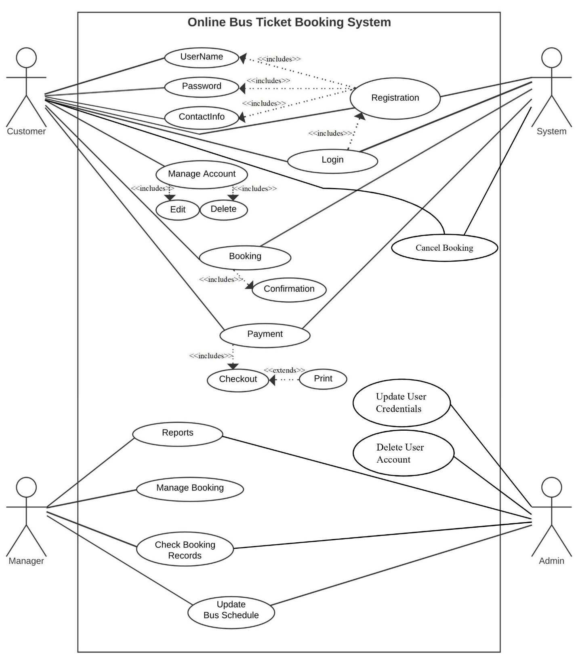

Use Case Diagram

**6.0 Stakeholder Analysis**

Our system has two stakeholders. First one is internal and another is external stakeholder.

**Internal Stakeholder**

Internal stakeholders include employees, owners, shareholders, and managers. They are simply anyone within the organization. In our project internal stakeholder will be,

**Employee**

Mainly employee will be primary internal stakeholder. Because Employees have significant financial and time investments in the organization, and play a defining role in the strategy, tactics, and operations the organization carries out.

**Developer**

They have the technological expertise necessary to advise executives on which features are feasible and how long each would take to build.

**Manager**

Manger are internal stakeholder because Employees of the company are invested in the company's performance to ensure they continue to be paid and retain their jobs. Depending on the nature of the business, employees may also have a health and safety focus.

**External stakeholder**

External stakeholders are those who do not directly involved with a company but are affected somehow by the actions and outcomes of the business.

**Suppliers**

Suppliers provide the raw materials or components that a company uses to create its products. A business may depend on one particular supplier that produces a superior or rare good, in which case the supplier has heightened importance.

**Government**

The government is an external stakeholder in all businesses. In fact, it is considered one of the major stakeholders since it collects taxes from these establishments in the form of corporate income tax and income tax from the employees of the company.

**Passenger**

The passengers can be considered as the most important external stakeholders. These are the people who will consume the end products or use the services of the company. They, therefore, decide whether a business succeeds or not, even though they are not concerned with its day-to-day running.

**7.0 Feasibility Study**

Preliminary investigation examines project feasibility, the likelihood the system will be useful for all. The main objective of the feasibility study is to set the technical and financial feasibility for adding new modules and debugging old running system. All systems are feasible if they are given unlimited resources and infinite time.

There are aspects in the feasibility study portion of the preliminary investigation:

* Technical Feasibility
* Financial Feasibility

**Technical Feasibility**

A technical feasibility study is an in-depth examination of tech factors related to the intended project. It touches things on our donation funding project like

* Hardware and software components,
* Technical risks and constraints,
* Compatibility with other IT systems, and
* Capabilities of our team.

**Financial Feasibility**

A system can be developed technically that will be used if installed must still be a good investment for the organization. In the financial feasibility, the development cost in creating the system is evaluated against the ultimate derived from the new systems. Financial benefits must equal or exceed the costs. The system is equally feasible. It does not require any additional hardware or software.

**8.0 System Component**

The application will have three different sorts of users. They are customer (passengers), manager & stuff, and admin. These users can use the different components of the system application.

**Registration & Login**

To use the Bus ticket booking application, users need to open an account with certain information. After completing the registration process, the users can login to their account. After logging in to their account, customers can know about the bus schedule of various destinations.

**Manage Account**

Customers can modify and delete their account. Customer can update his/her accounts information as per their needs.

**Reservation / Booking**

Customers can book bus tickets by checking various bus schedules of different destination. For ticket booking, customers can make payment through mobile banking, card payment and money transfer from the bank. Customer can also cancel their ticket if they are facing any troubles. The staff also can use the reservation features. The staff is a representative of the bus company and can also book tickets for passengers through this application. Managers also holds the authority of the ticket booking feature.

**Reports**

Bus company managers will be able to report the timings of the different bus destinations in advance. They can also report if the bus schedule is canceled due to any unavoidable reason. If the bus company manager finds any difficulties to operate this system, he can also report the issues.

**Manage Bookings**

Bus company manager can only use this features. In some specific cases they can book the tickets for the passengers.

**Check Booking Record**

The bus company manager can see the booking records of the bus. This features only for the managers. By this features they can monitoring the profit of for the business.

**Update Bus Schedule**

This features can only use by the managers and admin. The managers of the bus company can update the schedule of the bus. The admin can also the update the bus schedule. They can change the bus schedule according to their needs.

**Update Users Credentials**

Only admin can use this features. Admin can update the credentials of the passengers and customers. Admin can update the account information of the customers.

**Delete User Account**

This features can only use by the admin. Admin can remove the user account from the system if he finds the absence of the user or any irrelevant activities.

**9.0 Process Model to be followed**

In our project we want to follow the Waterfall model. The waterfall model is a traditional paradigm used in the life cycle of a system's development to design a system in a linear and sequential fashion. The model grows consistently from one phase to the next in a downward direction, which is why it is known as a waterfall model. In this Waterfall approach, the results of one phase often serve as the sequential input for the following phase. Especially it is suitable for some projects which projects have well defined requirements and there is no high uncertainty for the project.

In our project we want to apply waterfall process model. The first phase of our project is stakeholder analysis. In this phase we find out the stakeholders for our project. In the next phase we do the feasibility study for the project. Here we analysis both technical and financial feasibility for development of the system.

After analyzing the feasibility study, we collect the user requirements properly. The precondition for a successful project is collecting requirements from the user properly.

After analyzing the user requirements, we will begin investigating about the system design. Then we will start the program design for the system for our project. After analyzing the program design, the work will begin for the coding part of the system.

After creating the software system of our project the software will be sent for testing phase. If any bugs are found during the testing phase, the software will be reworked to fix the bugs. To fix the bugs for this software necessary steps will be taken in operation phase.

The waterfall process model also describes these steps for successful project completion. Our project steps are being followed by the waterfall process model. We collecting the user requirements properly. The aim of our project is to make the system software work as per the needs of the users. Before executing the project, we estimate the effort to predict how much time, effort and budget is required to develop and maintain a software. This process will helpful for reducing the risk and uncertainty for a project. If there is any problem in the developing phase of our project, we can go back to the previous phase while working on one phase in our project. The steps mentioned in the waterfall process model will be gradually applied to for this project. For this reason we want to apply the waterfall process model in our project.

**10.0 Effort Estimation**

The goal of our project is to create the “Online Bus Ticket Booking System”. We are assuming that the SLOC (Source Lines of Code) that we require here after analyzing all the components.

SLOC = 10,000

Now we need to figure out the effort, development time, and required number of people.

Suppose that, our software project type is organic, the values of the Coefficient<Effort Factor> =2.4

P = project complexity = 1.05

SLOC= 10,000

T= SLOC-dependent coefficient = 0.3

Now,

Effort = PM = Coefficient*(SLOC/1000) ^P

PM = 2.4*(10000/1000) ^1.05

= 26.93

Development Time= DM= 2.5*(PM) ^T

= 2.5*(26.93) ^0.38

= 8.74

= 9 [In months]

Required Number of People = ST

= PM/DM

= 26.93/8.74

= 3.08

= 3

**Work Break Down Structure**

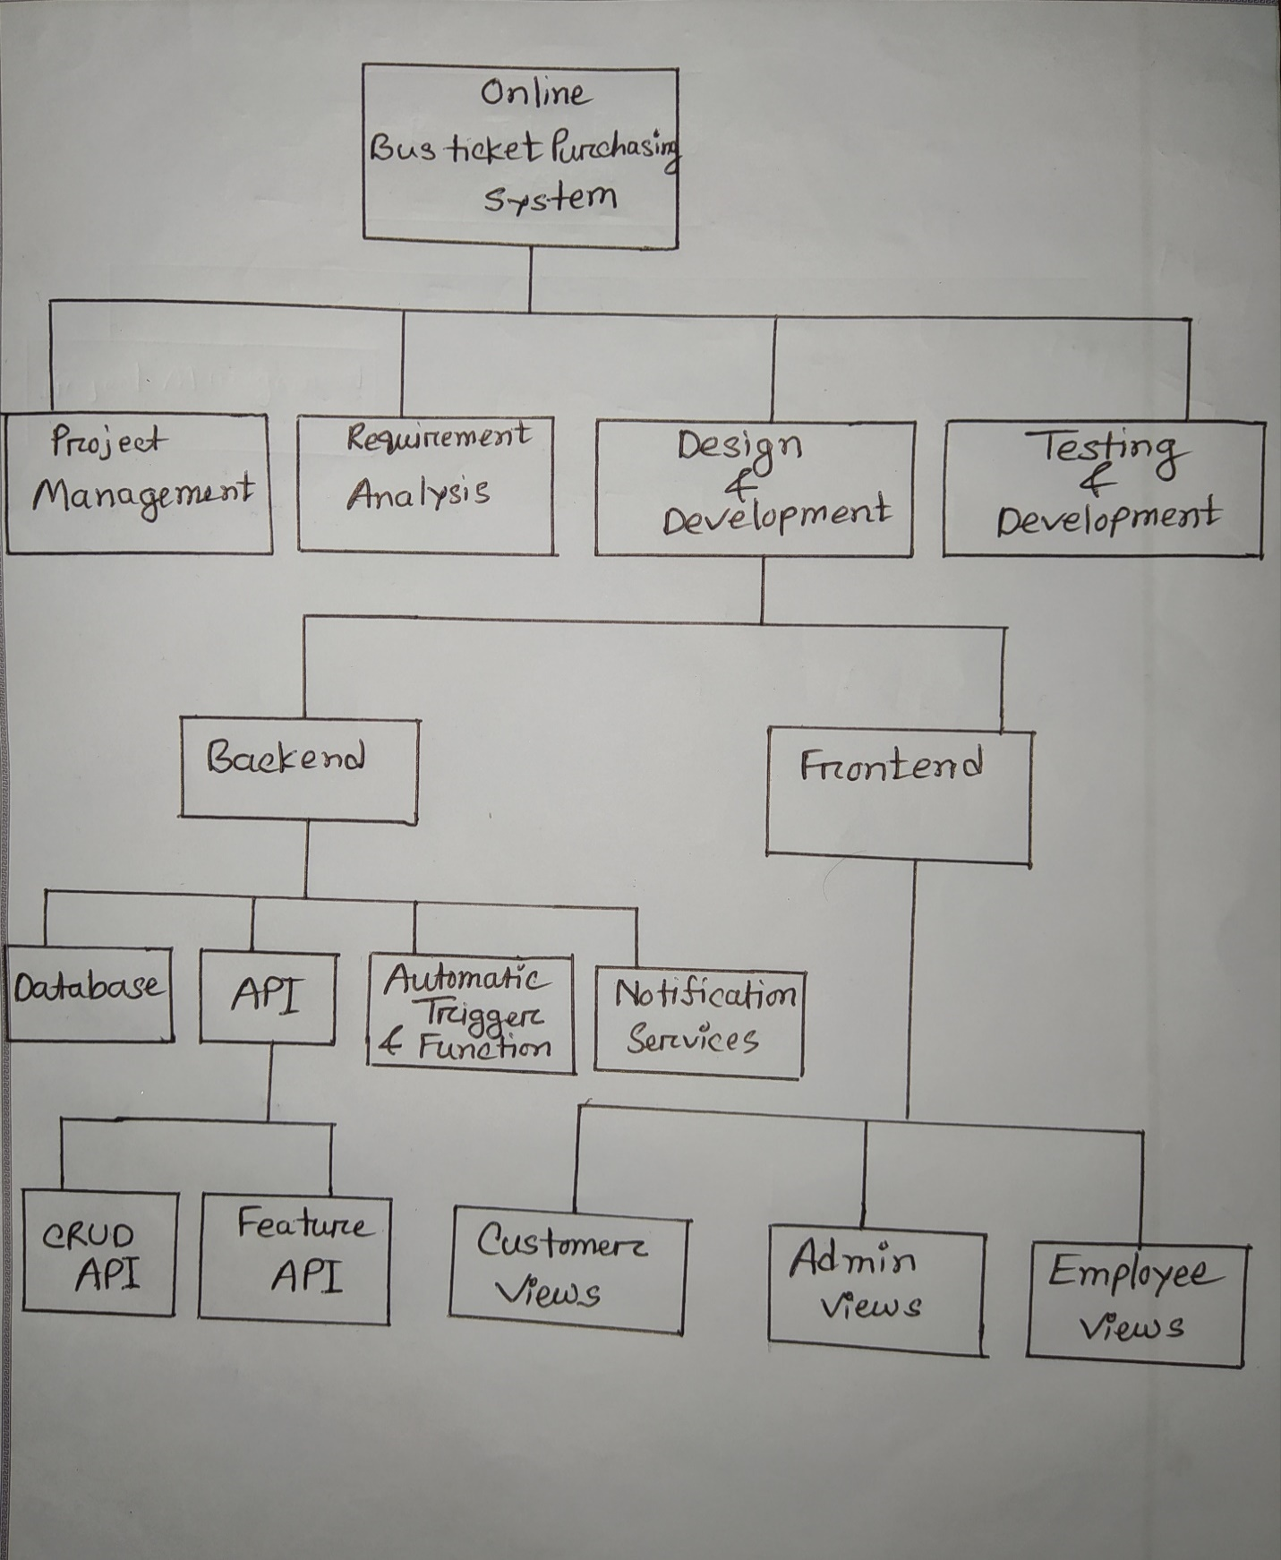

**11.0 Activity Diagram**

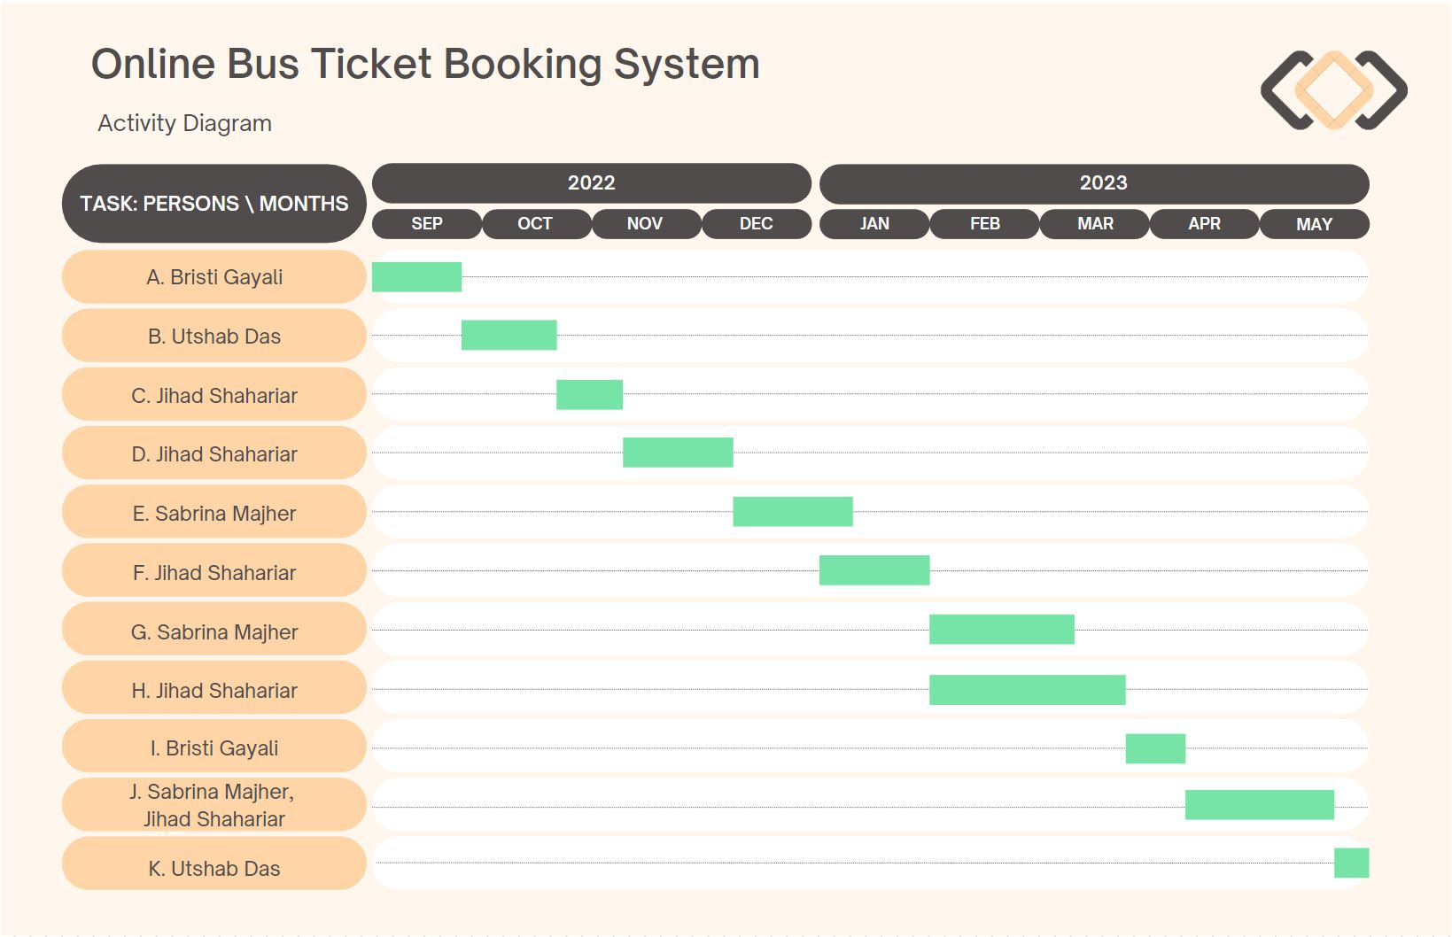

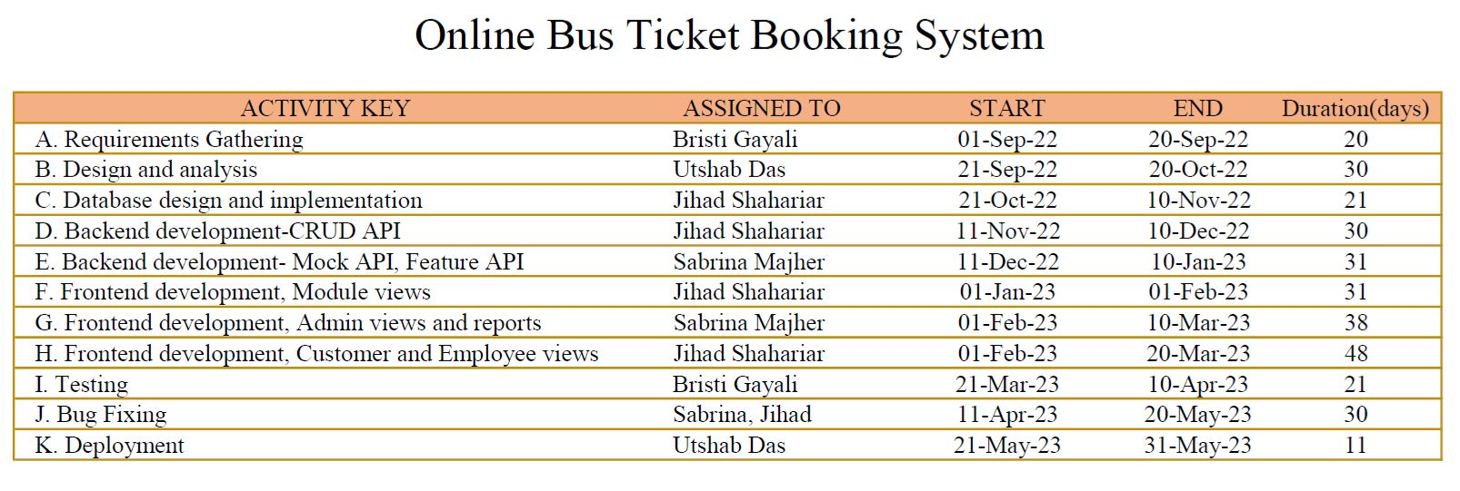

**Precedence Network Diagram**

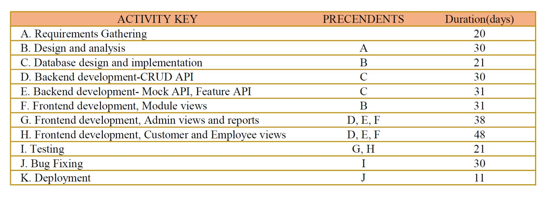

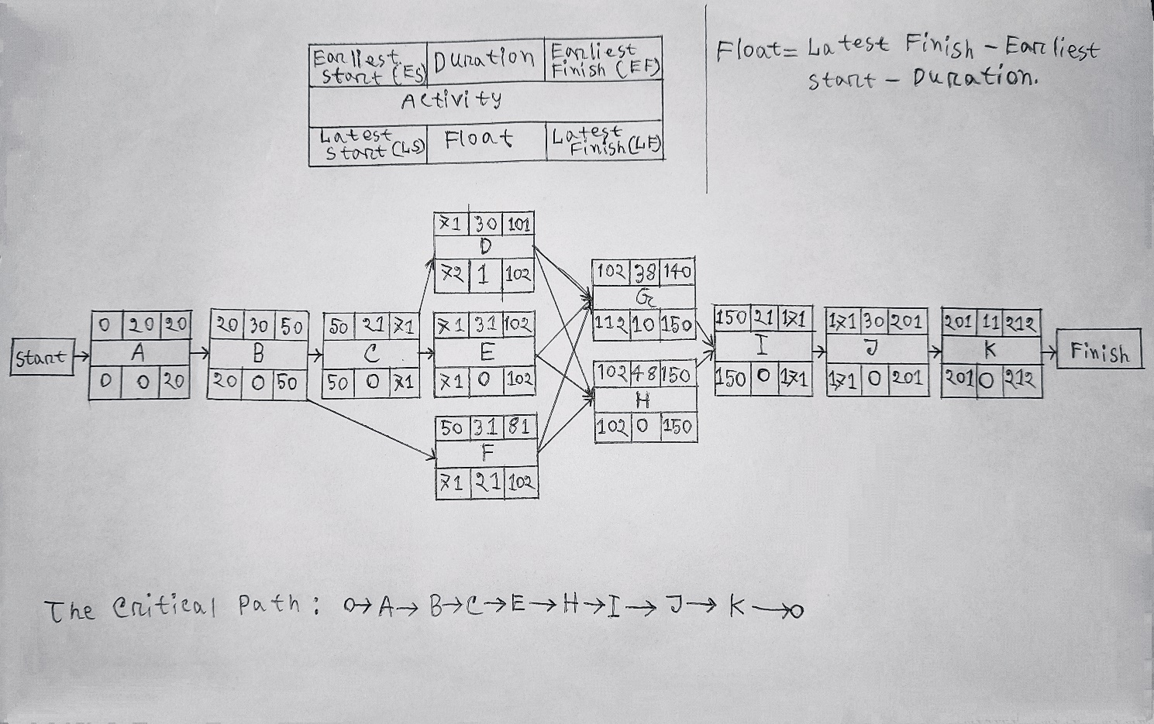

**12 .0 Risk Analysis**

|  |  |  |  |  |
| --- | --- | --- | --- | --- |
| Risks | Category | Probability | Impact | RMMM |
| Size estimation significantly | PS | 30% | 2 | - Use multiple size estimation techniques to verify the estimation.  - Software to be built or modified. |
| Business impact | BU | 20% | 2 | - associated with constraints imposed by market place. |
| Developer inexperienced | DE | 40% | 3 | - Define required experiences for the job clearly while recruiting. |
| Customer changes requirement at development stage | CU | 60% | 2 | - Communicate scope of changes and the change control policy clearly with the customer  - Have a change control board |
| Technology stack gets deprecated | TE | 20% | 3 | - Use LTS versions where possible  - Decouple as much as possible so replacements are possible. |
| Breaking changes in prebuilt packages | PR | 30% | 2 | - Prevent automatic updates to the repository modules and packages  - Analyses each update before applying the updated version  - Use a version control system |
| Staff size and experience | ST | 15% | 1 | - Communicate frequently  - Secure early funding  - Collect an upfront payment |

**Impact values**

Catastrophic -1; Critical – 2; Marginal – 3; Negligible – 4

**13.0 Budget for the Project**

**Budget Estimation**

From the effort estimation we find that development time for the project is 9 months and required number of people needed for the project are 3 developers.

Duration in weeks = 9*4 = 36 weeks Office days

Per week working days = 5 days

Working hours = 7 Hours

So, per week working hours is = (5*7) hours = 35 hours

So Total Working hours is = 35*36= 1260 hours.

Developer salary is = 800 Taka/ Hour

Total developers Salary = (800* 1260) = 1008000 Taka

|  |  |  |
| --- | --- | --- |
| **Expanse** | **Amount** | **Total Amount** |
| Salary for 3 developers |  | 10,08,000 |
| For Requirement analysis  Cost for 1 months | 22*8*400 | 70,400 |
| Transport |  | 10,000 |
| 9 months office rent | 9*25000 | 2,25,000 |
| Hardware Expanse |  | 80,000 |
| 4 months maintenance cost | 16*9*1200 | 1,72,800 |
| Training Cost |  | 10,000 |
| Now Total Estimation Cost is |  | 15,76,200 |

**Profit**

15% of total estimation cost = 15,76,200 *15% = 2,36,430

Total budget of the project = 15,76,200 + 2,36,430

= 18,12,630

**The total budget for the project is 18, 12,630 Taka.**

**14.0 Conclusion**

Finally, after completing a whole project module, we will get user feedback. An online bus ticket management system software should be ensure online ticket and management. This project will contain customer iteration, and project management must quantify, objectify, separate, and allocate roles effectively. Given the total project timeline of 5-10 months, the most difficult component of this project is maintaining on track and finishing the task on time. Nowadays people are looking for the online system. Since it is the most accessible and convenient way to obtain information. In Bangladesh, there are a lot of online ticket booking organization. Our intended system is a web-based application that will incorporate services required by customers . It is not only for customers it will also serve owners, as well as owners of buses.